
Story
Date | 28 October 2026
Team ID | EN25IT3010095
Project Name | EV Market Performance and Insights
Maximum Marks | 5 Marks
By using stories in Tableau, you can effectively communicate complex data in a way that is both interactive and engaging, making it easier for the audience to follow along and understand the insights. It’s a tool for data storytelling, allowing you to present insights in a cohesive, engaging way that takes viewers through a logical progression of findings or analyses.
In Tableau, Story is a feature that allows you to create a sequence of dashboards, visualizations, and text to present data insights in a cohesive and narrative-driven way. It's like a slideshow within Tableau that guides the audience through a series of data points, helping them understand key insights, trends, or outcomes of your analysis.
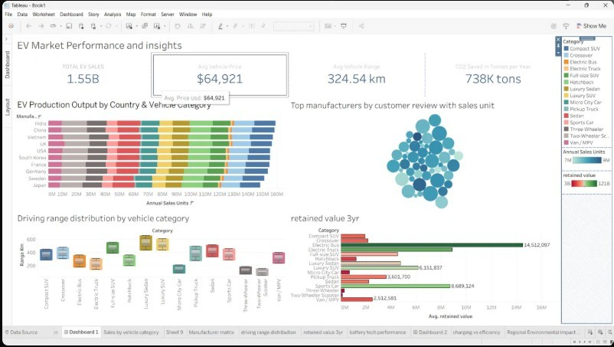
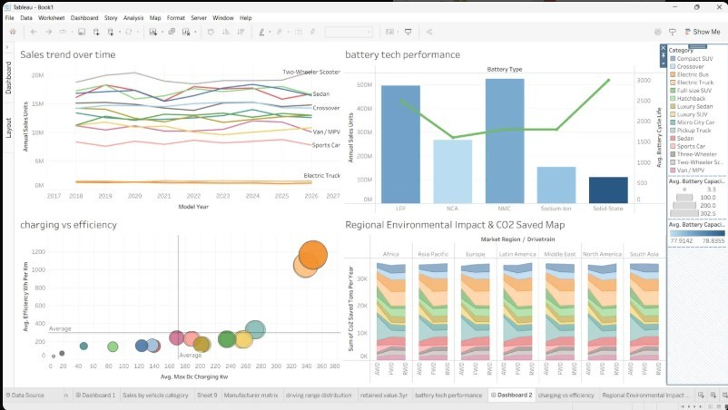
Observations:
- Story Point 1 - Market Snapshot: 1.55B total EV sales at an average price of $64,921, with India, China and Vietnam leading production output.
- Story Point 2 - Range and Value: Luxury Sedans and SUVs offer the longest range, and Electric Buses retain the most value after 3 years (14.5M).
- Story Point 3 - Sales Trend: Annual sales are stable from 2018 to 2026, led by Two-Wheeler Scooters, while Electric Trucks sell the least.
- Story Point 4 - Battery Technology: NMC and LFP batteries lead in sales units, while SolidState and LFP show the longest cycle life.
- Story Point 5 - Charging and Impact: High-capacity vehicles charge fastest (about 350 kW) but use more energy per km, and 738K tons of CO2 are saved per year across regions.
Activity 2:
Publish Story on Tableau Public and Paste Public link below
https://public.tableau.com/views/HarshalParetadataanalyticswithtableauSmartbridge/ Dashboard1?:language=en-US&:sid=&:redirect=auth&:display_count=n&:origin=viz_share_link

